## Using conditionally visible icons in the name badge

1. Before you open the Namebadge, save a backup, otherwise you may lose all your editing to the name badge.
2. On the Toolbar, click the scripts button
3. Paste the following text, you will need to edit this for your event, however EA support will be able to assist you with this.

private void calculatedField1_GetValue(object sender, DevExpress.XtraReports.UI.GetValueEventArgs e) {

dynamic rowData = e.Row;

dynamic marketing = rowData.Marketing;

foreach (var tag in marketing)

{

if (tag.Tag.Name == "Company Background") {

e.Value = "True";

}

}

}

1. Repeat the above step for each image you wish to add, changing the calculated field number while doing so (ie the second is “calculatedField2_GetValue”). You may also wish to name these after the tag, ie if its dietary, call it Dietary_GetValue
2. On the Toolbar, click the scripts button again
3. Right Click on the Field List located on the Right Hand Side and select “Edit Calculated Fields”
4. Add a new Calculated Field
5. Change the (Name) to your desired name
6. Under Scripts, select the calculated field.

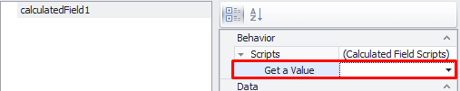

1. You will need to repeat 7-9 for each image you are adding
2. Select the image you wish to be conditionally visible
3. On the right hand side in property grid, change the “Visible” to No

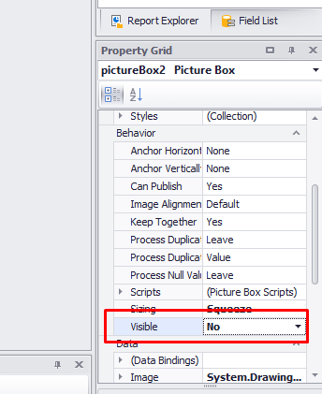

1. On the image, select the formatting rules by clicking the triangle, then click “Formatting Rules”

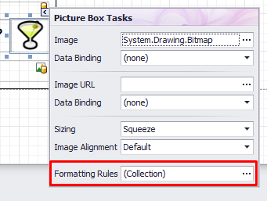

1. Click “Edit Rule Sheet”
2. Click the **+** button to add a new rule
3. Click the … next to Condition
4. Set the condition to the following format: [calculatedField1]=='True' You will need to change the title from calculated field to the appropriate title.
5. Change the Visible from (Not set) to “Yes”
6. Add this rule to the control by using the > button
7. Exit out of the formatting and have a look at the “Print Preview” to check the appearance.
8. If everything has been done correctly, you should see the name badges applying the icons where appropriate and you can save and exit.
9. If the Print Preview shows an error message **Do not save the name badge!** This can corrupt it and you will need to revert to the backup.

If you have any questions please contact EA support